Region One Board Conference Call
Minutes
Wednesday, January 16, 2019

On the call: Beverly, Sue, Margie, Nadine, Cindy, Leslie, Pat

The meeting opened with the Serenity Prayer led by Cindy followed by the reading of the Purpose of R1 & Our Mission Statement led by Pat.
WSBC 2019
Board members were asked for updates to the WSBC delegate attendance list. Pat reminded the Board that although WSO publishes a preferred deadline for delegate registration, delegates can register as late as the first day of WSBC. If the Board votes to accept the BFDS recommendations for the use of excess funds, there will be additional funds available for delegate support.
Calendar and IGR /Outreach Visit
The Board reviewed Intergroup Renewal and Outreach visits scheduled so far this year:
- February 23rd Greater Columbia IG
- March 16th North Cascade IG
- April 13th Oregon IG

No other requests have been received. Pat suggested we review the focus of 2019. Beverly shared the 2019 IGR form on-screen which reads
- “Intergroup Renewal (IGR) or an IGR “refresher”
- “Strong Meetings, Strong Intergroups, Strong Personal Recovery”
- And /or any recovery topic chosen by your intergroup

Pat will send out the IGR form to IG Chairs and encourage them to schedule a date for a visit. Beverly and Margie led a workshop for “Catch the Wave” IG that covered three areas: strong personal recovery, strong meetings, and a mini-IG renewal. Beverly will send the workshop outline to the Board. All agreed that in order to make more visits during the year, each visit would involve two board members rather than the entire board.

Strategic Planning 2019: Beverly asked the Board to arrive in Portland by dinnertime on Thursday, April 11 and plan to stay at the Monarch Thursday and Friday nights. Sue will book rooms.

Liaison Roles – Questions / Concerns / Updates
Each Board member was given time to talk about work with their liaison intergroups and ask for input from the other Board members. Pat would like to see additional IG’s participate in the quarterly reporting survey and is happy to walk any Board member through the process. It’s simple and quick.

Financials
Due to technical issues, the Board was unable to review the monthly financials. Allocation of excess funds was discussed. Motion to accept the BFDS recommendation for the use of excess funds and increase allocations by the amount specified. Motion carried.

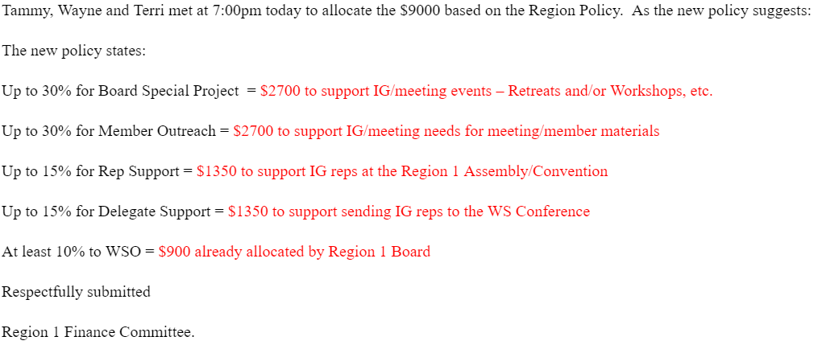

Leslie and the BFDS will develop a process and/or an application for disbursement of these funds.

R1 speaker meeting / conf call
The Board agreed to a quarterly schedule. Top topics of interest to members seem to be body image, letting go of guilt and shame, how to be a good sponsor, “I Love OA”. Beverly will set up and do the recording. Nadine will lead the coordination effort for the calls and each Board member will assist her.

2019 R1 Convention
Sue asked for Convention brochure edits and budget comments by January 23rd.
Oregon IG has decided on a three-speaker approach: one from outside the region, one inside region 1 and one from Oregon IG. The Board will get a list of speakers for approval.

The meeting adjourned at 5:55 pm with the Serenity Prayer.

Next meeting: Wednesday, February 20, 2019 at 4:20pm Pacific Time

Respectfully submitted,

Cindy C.
Region 1 secretary

